# PARTITION BY a Column: Legia Warszawa Match Analysis

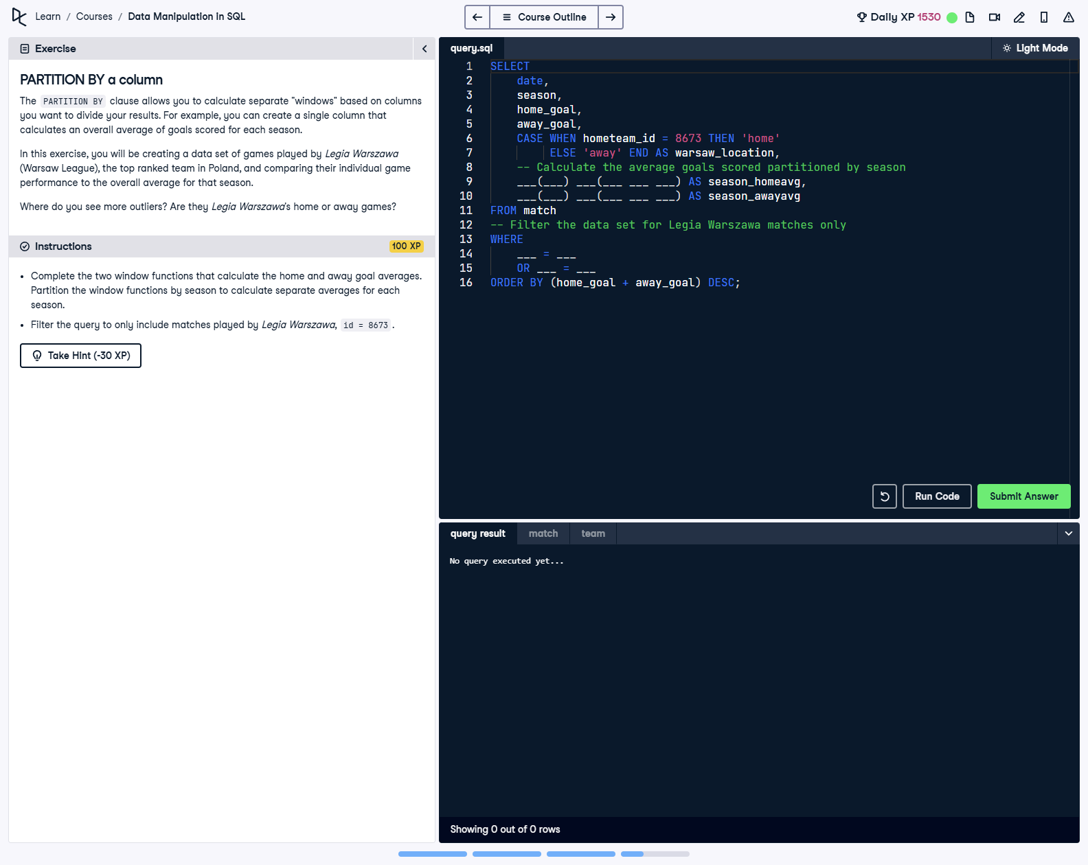

## Question

Using the PARTITION BY clause, create a data set of games played by Legia Warszawa (team ID = 8673). Calculate the average home and away goals partitioned by season, and include each game's details. Classify matches as home or away games, filter only for Legia Warszawa matches, and order by total goals scored.

## Corrected Solution

SELECT  
 date,  
 season,  
 home_goal,  
 away_goal,  
 -- Determine if the match was home or away for Legia Warszawa  
 CASE WHEN hometeam_id = 8673 THEN 'home'  
 ELSE 'away' END AS warsaw_location,  
 -- Calculate the average home goals partitioned by season  
 AVG(home_goal) OVER(PARTITION BY season) AS season_homeavg,  
 -- Calculate the average away goals partitioned by season  
 AVG(away_goal) OVER(PARTITION BY season) AS season_awayavg  
FROM match  
-- Filter the data set for Legia Warszawa matches only  
WHERE hometeam_id = 8673 OR awayteam_id = 8673  
-- Order the query by the total goals scored in descending order  
ORDER BY (home_goal + away_goal) DESC;

## Explanation

This query filters for matches played by Legia Warszawa using the hometeam_id and awayteam_id columns. It uses the PARTITION BY clause in the AVG() function to calculate separate seasonal averages for home and away goals. The CASE statement classifies matches as 'home' or 'away' depending on whether Legia Warszawa was the home team. Finally, the results are sorted by the total number of goals scored in descending order.